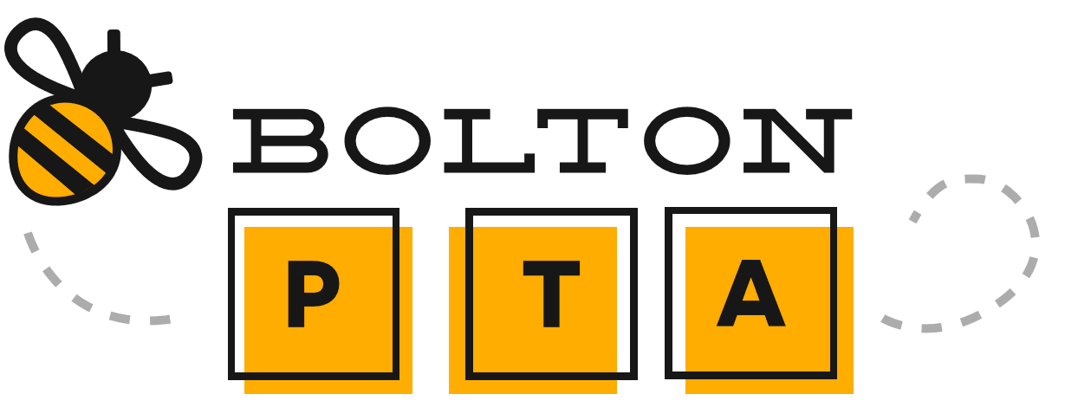
Calendar of Events 2020-2021

DATE | TIME | EVENT | LOCATION
September 2020
9/23/20 | 6:30 pm | Fall General PTA Meeting | Zoom
9/25/20 | TBD | PTA Fall Fundraiser | TBD
October 2020
10/22- 10/23/20 | TBD | Conferences: Meals for Teachers | TBD
10/30/20 | TBD | Family Event: Pumpkin Palooza! | TBD
January 2021
1/20/21 | 6:30 pm | Winter General PTA Meeting | TBD
February 2021
2/5/21 | 5:30 pm | Family Event: Pizza Bingo | TBD
March 2021
3/3/21 | 6:30 pm | Spring General PTA Meeting | TBD
3/18 -3/19/21 | TBD | Conferences: Meals for Teachers | TBD
May 2021
5/12/21 | 6:30 pm | Final General PTA Meeting | TBD
TBD | TBD | PTA Fundraiser: Family Movie Night | TBD

Please note, all of the events and programs listed in the calendar above are subject to change due to and in response to current Covid-19 guidelines. For current event information, please visit www.boltonprimarypta.com and our Facebook Page (Bolton PTA).

